# [www.titalcompany.com](https://titalcompany.com/)

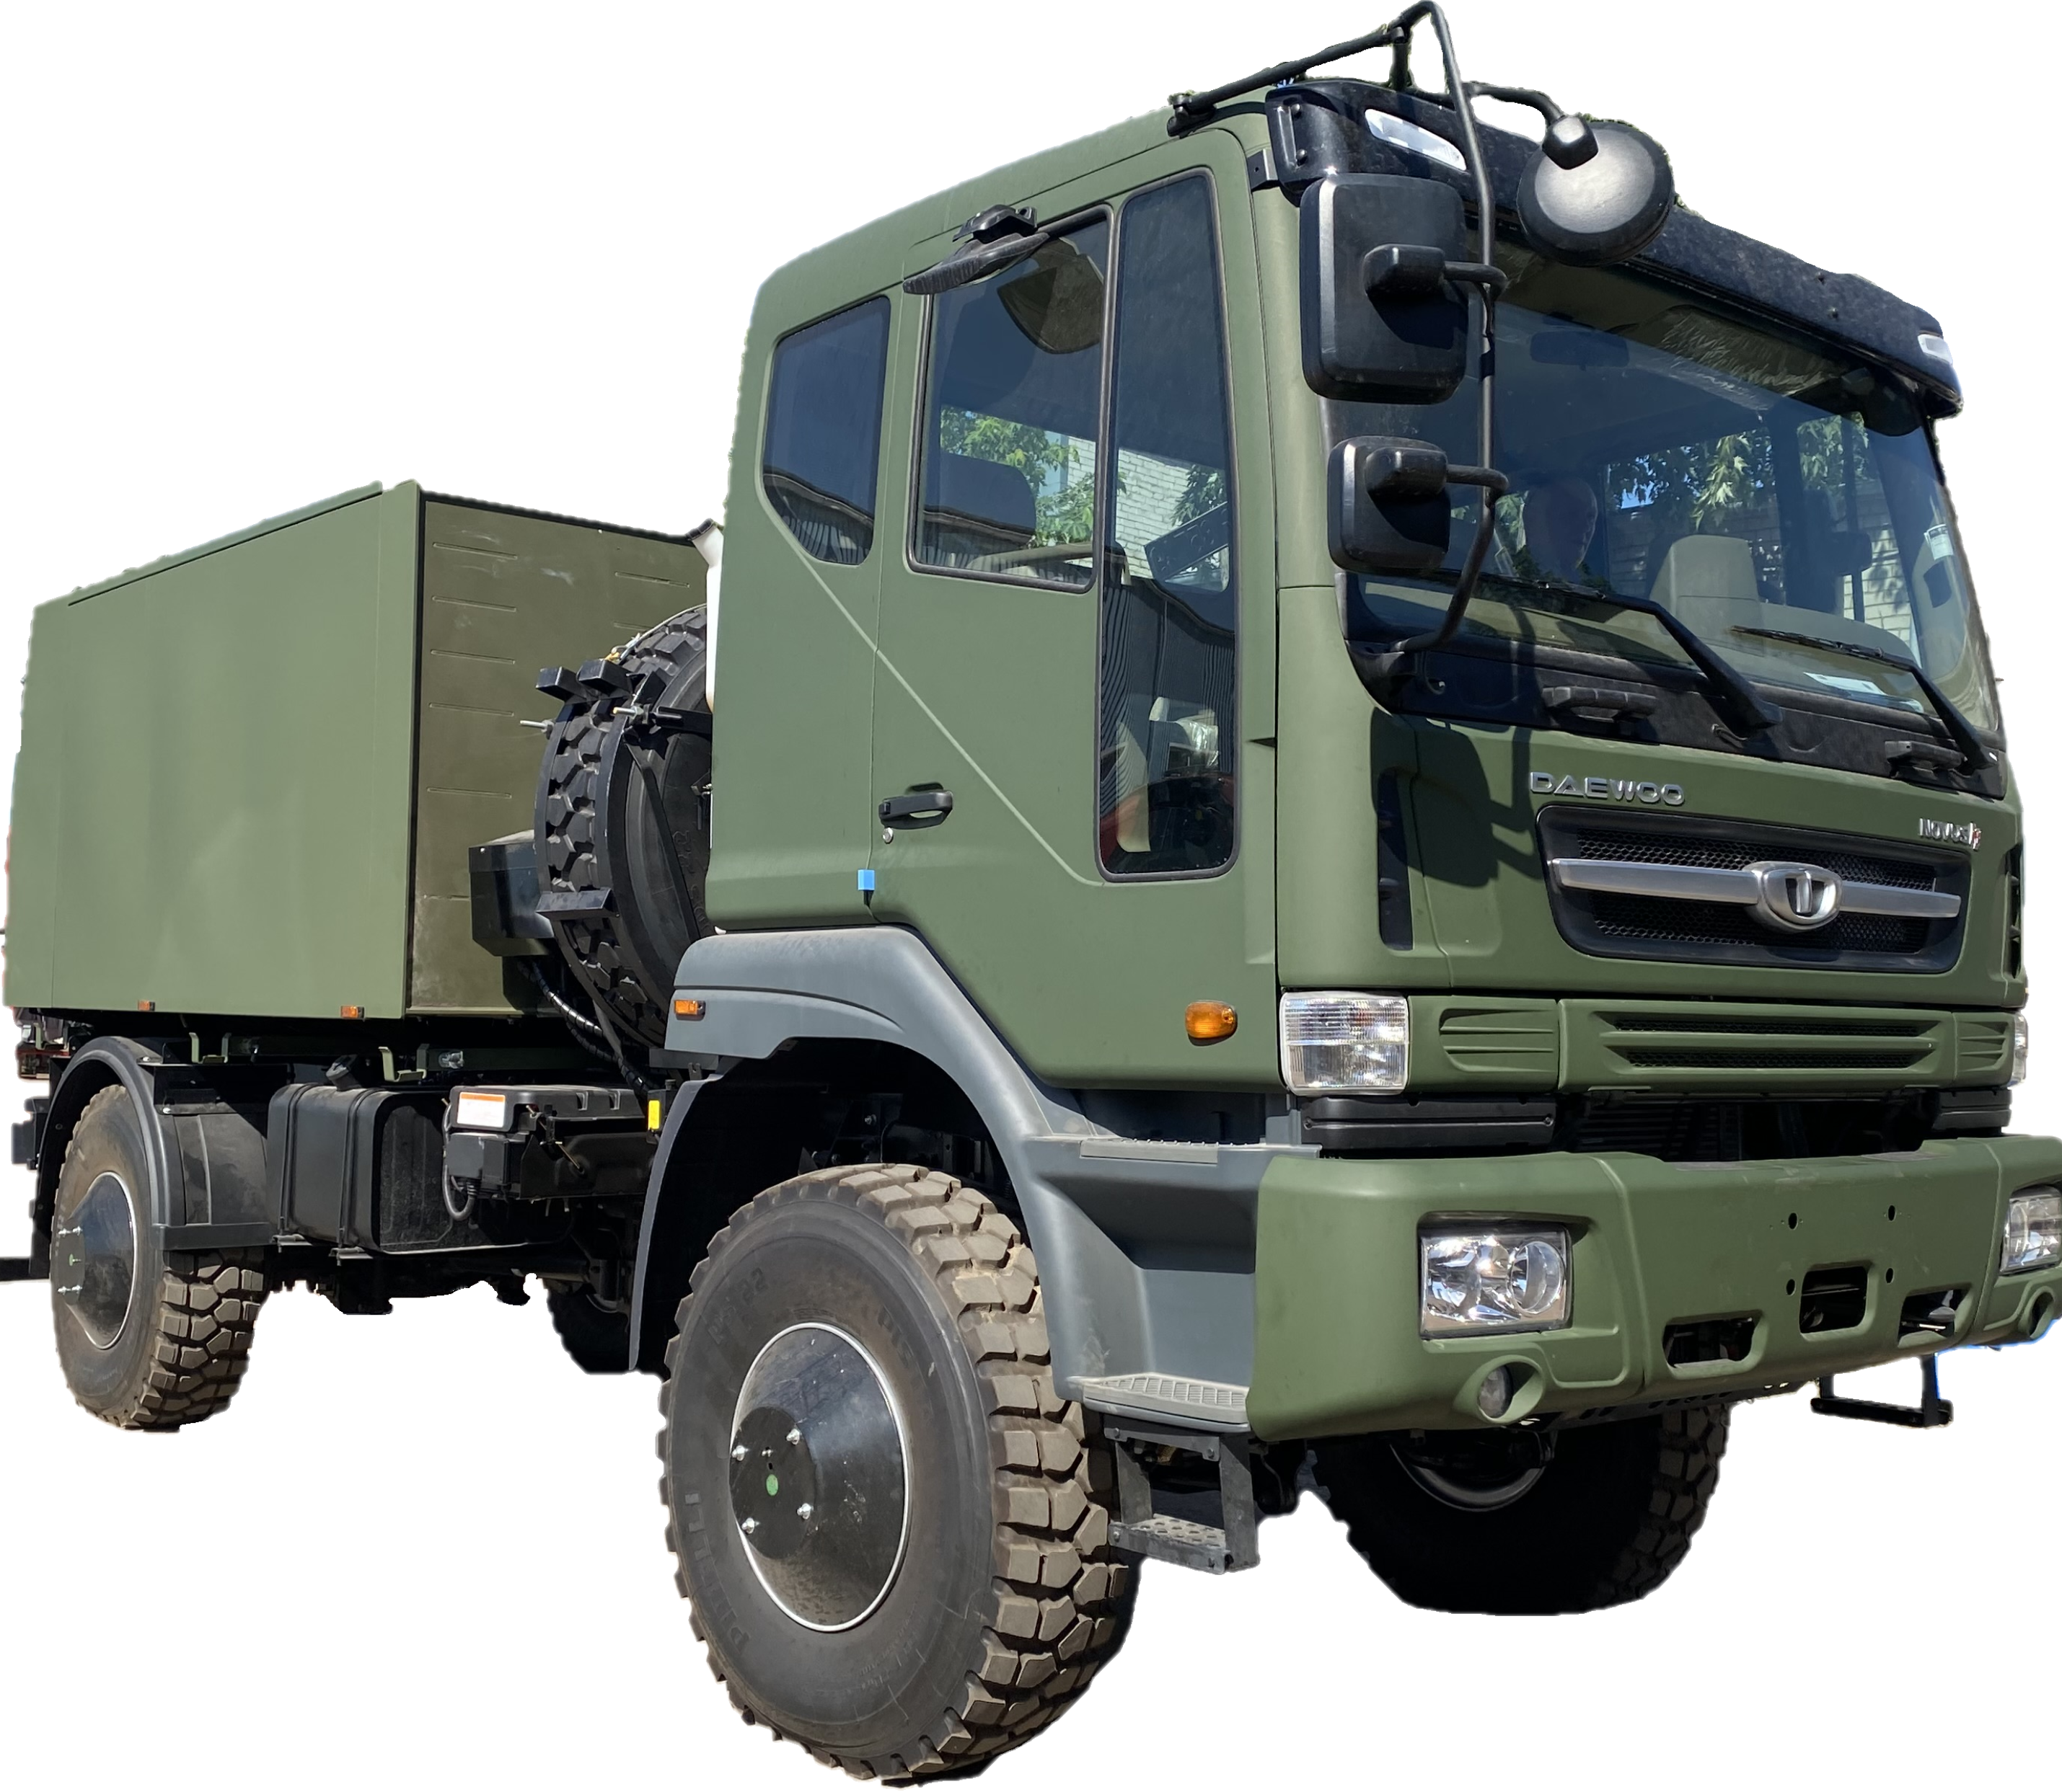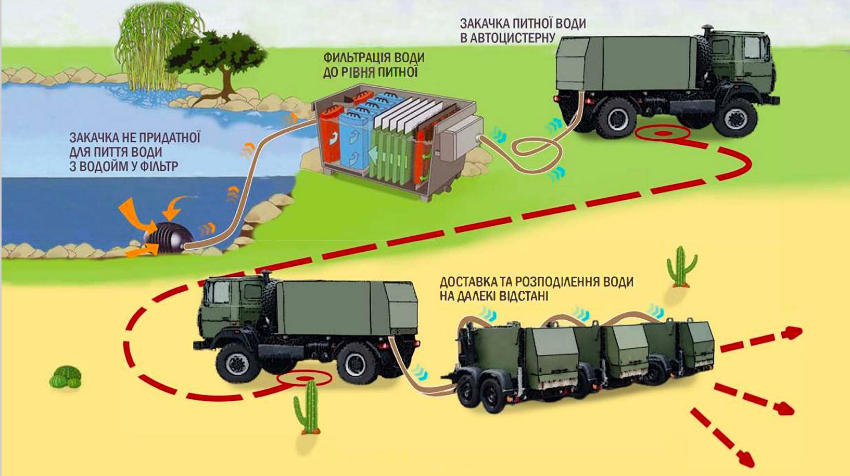

|  |  |  |
| --- | --- | --- |
|  |  |  |
|  |  |  |
|  |  |  |

POLYPROPYLENE DRINKING

WATER TANKER-THERMOS

The lack of drinking water, especially in countries with hot climates, during hostilities and natural disasters, leads to significant losses of the military and the civilian population. A thermos tank for drinking water is designed for pumping, transporting, and distributing drinking water in places where it is needed.

**ЛОГІСТИКА ПИТНОЇ ВОДИ**

**ADVANTAGES**

# www. titalcompany. com

“VITALITY” AFTER SHOOTING

## Fragments and bullets with low kinetic energy get stuck in

## viscous polypropylene, while those with high kinetic energy pass through and the hole is “tightened”.

## The tank retains its operational properties. REPAIRABILITY

**Holes in polypropylene are filled in the field with a heated rod.**

**Stainless steel tanks are virtually unrepairable**

**7, 62 ММ**

**100 М.**

**5, 45 ММ**

**9 ММ**

**50М.**

**5, 45 ММ**

**50М.**

**20 М.**

**7, 62 ММ 50 М.**

**TITAL others**

LIGHTER THAN A METAL TANK

With a vehicle carrying capacity

**CAPACITY**

**8 Т.**

## “HONEYCOMB” CONSTRUCTION

**THE UNIQUENESS OF THE DESIGN IS IN THE DIVISION OF THE ENTIRE INTERNAL VOLUME OF THE TANK BY PARTITIONS WITH AN AREA OF NOT LESS THAN 95% INTO COMPARTMENTS OF 500-700 LITERS, WHICH HAVE SMALL OVERFLOW HOLES IN THE LOWER PART OF THE PARTITIONS FOR LIQUID OVERFLOW.**

**7000 L. 5000 L.**

THIS SIGNIFICANTLY INCREASES THE TRANSVERSE AND LONGITUDINAL STABILITY OF THE VEHICLE WHEN TURNING AND BRAKING.

THERMAL INSULATION PROPERTIES

TEMPERATURE DIFFERENCE IN 10 HOURS, WITH A DIFFERENCE BETWEEN WATER AND SURROUNDING ENVIRONMENT TEMPERATURES OF 30 °C – NO MORE THAN 2 °C. TANK – THREE-LAYER, THERMAL INSULATED

## CORROSION RESISTANCE AND NEGATIVE WETABILITY

**Provide high sanitary and hygienic parameters**

**LAYOUT OPTIONS**

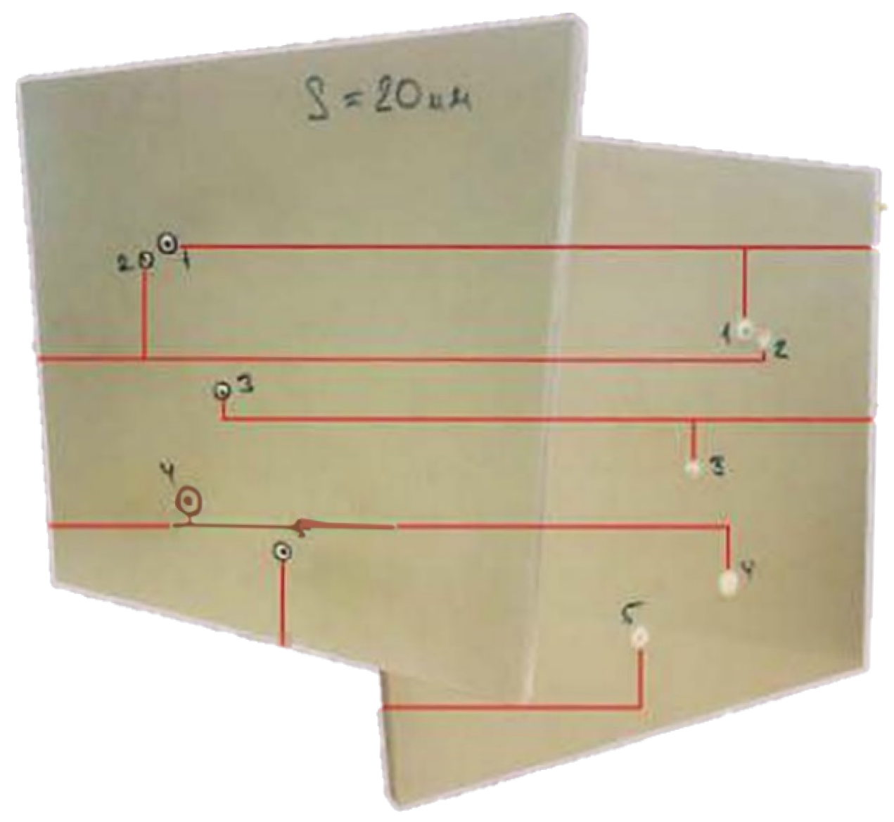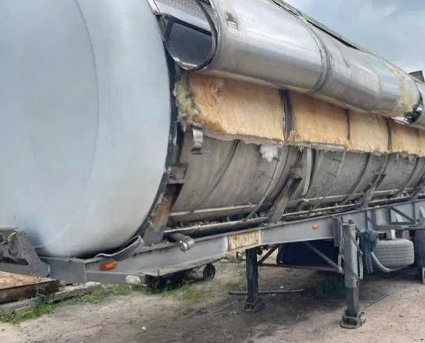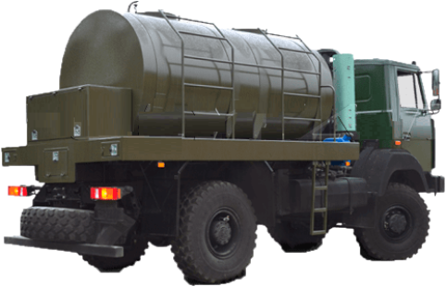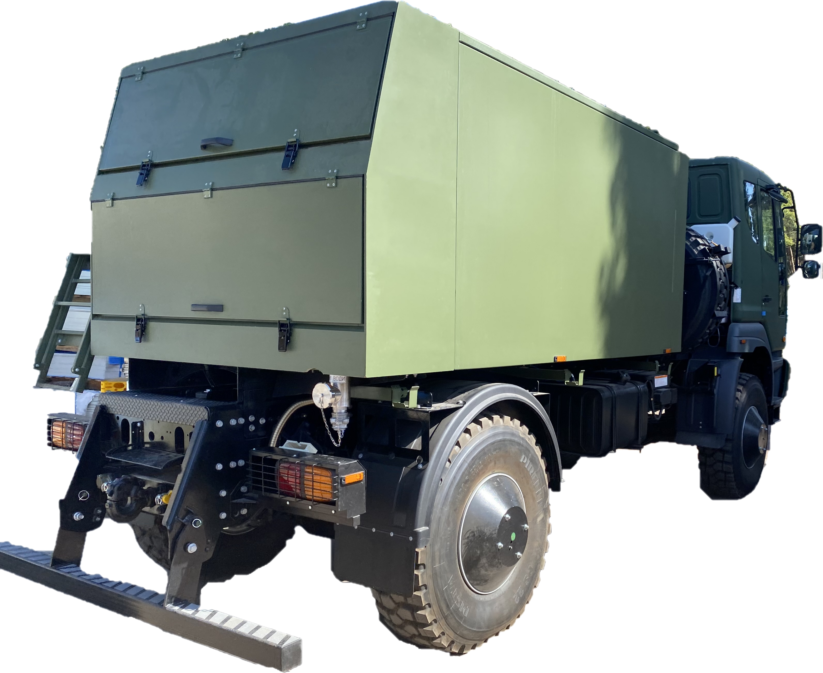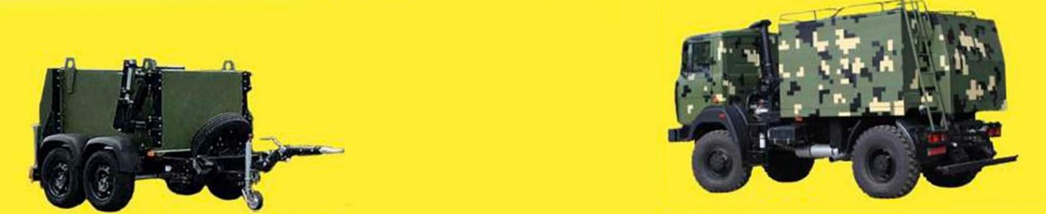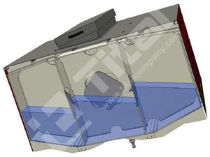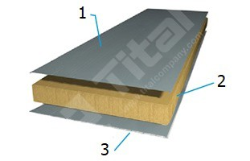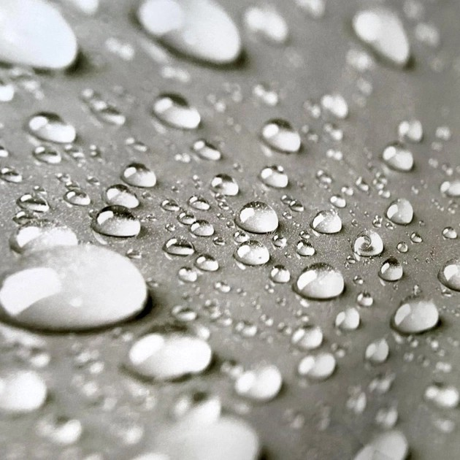

**Up to 5000 L Up to 12000 L and more**